**ABSTRACT :**

This project is basically about an implementation of innovative mechanisms to a rider’s helmet to bring out the following advantages –

* Internet of Things(IoT) based traffic emergency system
* Internet of Things(IoT) based traffic guidance system
* Extensive protection from sun strokes
* GPS tracking

All these facilities are to be implemented on the helmet with maximum cost efficiency to make the final product within the reach of Indian common man.

**PRESENT PROBLEMS :**

* There has been a multiple-fold rise in number of road accidents in the recent days and many-a-times, the emergency services have faced the difficulty on timely response to the situation.
* In large cities, sometimes the emergency services find it difficult to locate the spot of the accident as based on a phone call.
* Companies(logistics, customer service) face difficulties in tracking the vehicles of their employees

**IoT BASED TRAFFIC EMERGENCY SYSTEM :**

* Here the helmet will be mounted with appropriate sensors at appropriate positions on the helmet. They are calibrated to sense high impact due to any accident or crash.
* Once they detect the designated input, the rider’s location is immediately sent to a cloud of hospitals where the nearest hospital is notified about that so that ambulance can reach the spot immediately.

WHAT ARE THE THINGS HERE?

1. Rider’s Helmet
2. Ambulance
3. Hospital

CROSS SECTIONAL DIAGRAM :

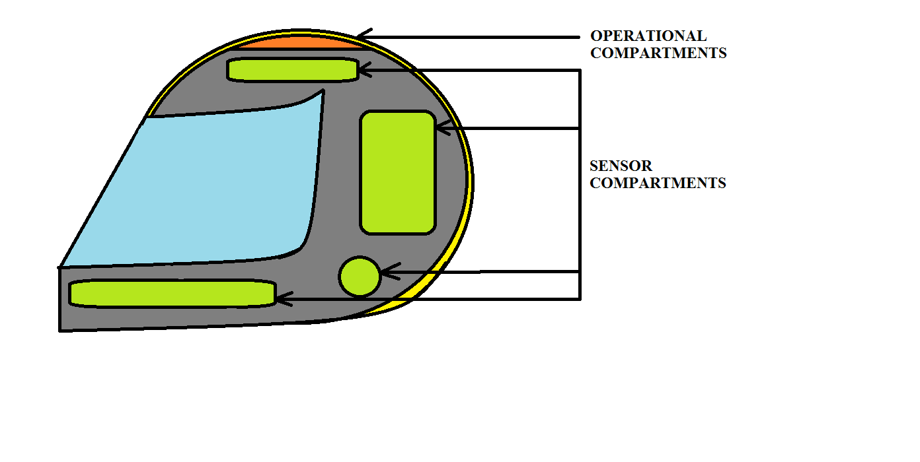

**FORCE SENSING RESISTOR :**

* Force-sensing resistors consist of a conductive polymer, which changes resistance in a predictable manner following application of force to its surface.
* The sensing film consists of both electrically conducting and non-conducting particles suspended in matrix. The particles are sub-micrometre sizes, and are formulated to reduce the temperature dependence, improve mechanical properties and increase surface durability. Applying a force to the surface of the sensing film causes particles to touch the conducting electrodes, changing the resistance of the film. As with all resistive based sensors, force-sensing resistors require a relatively simple interface and can operate satisfactorily in moderately hostile environments. Compared to other force sensors, the advantages of FSRs are their size (thickness typically less than 0.5 mm), low cost and good shock resistance.

FUNCTIONAL SCHEMATIC :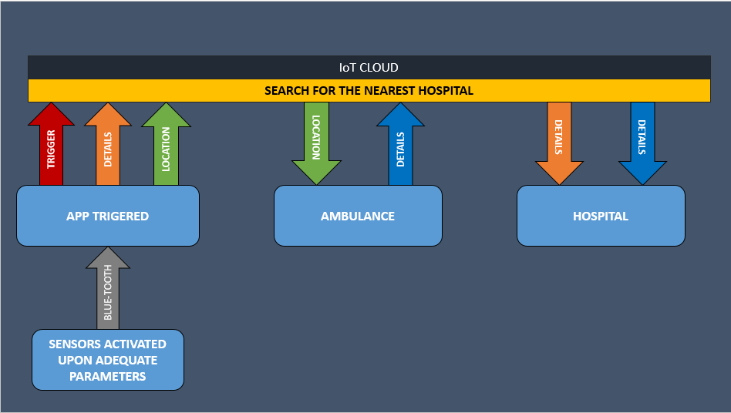

**ADVANTAGES :**

* Immediate response to any accident by the emergency services since all of them become a part of network(of things).
* The location of the accident is too updated to the emergency services so that finding the location wont be such a trouble.
* Details of the personnel is also updated to the emergency service centre so that formalities of paper-work may be completed in before hand.

**IoT BASED TRAFFIC GUIDANCE SYSTEM :**

* Here the rider’s helmet is in connection with the IoT cloud where the traffic signals of the city are also connected.
* Using this the rider will be notified of the traffic conditions and hence can prioritize his routes

What are the “Things” in this project??

1. Helmet
2. Traffic signal poles

**EXTENSIVE PROTECTION FROM HEAT STROKES :**

The helmet will be equipped with a detachable layer which would consist of a layer of high water adsorbing inert chemical sandwiched between the holding layers of fabric. When added the cool water, the chemical retains the low enthalpy as long as 4 hours.

**ADVANTAGES :**

1. The riders are provided with extensive protection from heat strokes in hot sunny days as it prevents dehydration and ensures constant supply of blood to the brain.
2. This reduces the cases of accident by a large number.
3. This attachment is very handy and can be detached for cleaning and can also be reused.

**BUSINESS MODEL :**

1. REVENUE MODEL -

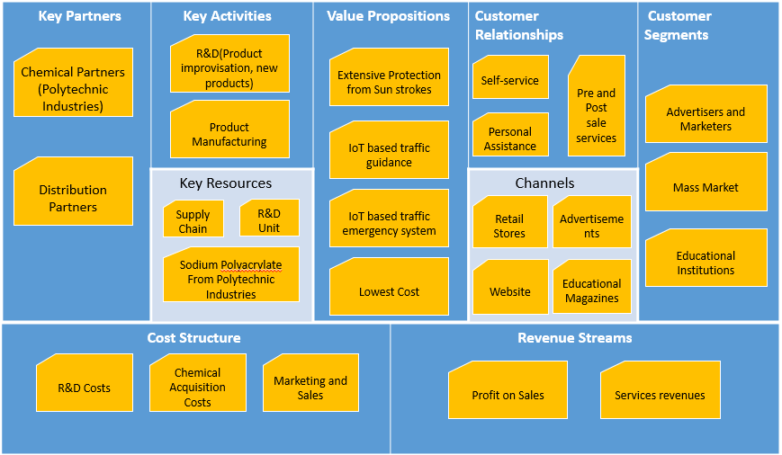

1. COST ESTIMATES :



TEAM MEMBERS :

1. SAILESH PATRA – 13BCE1119
2. JAGMOHAN SINGH – 13BCE1056
3. MARLA AKHIL REDDY – 13BCE1078
4. CHAVA SAITEJA – 13BCE1032

PROJECT REPORT

GOZWHIT

A SMART AND SECURE HELMET